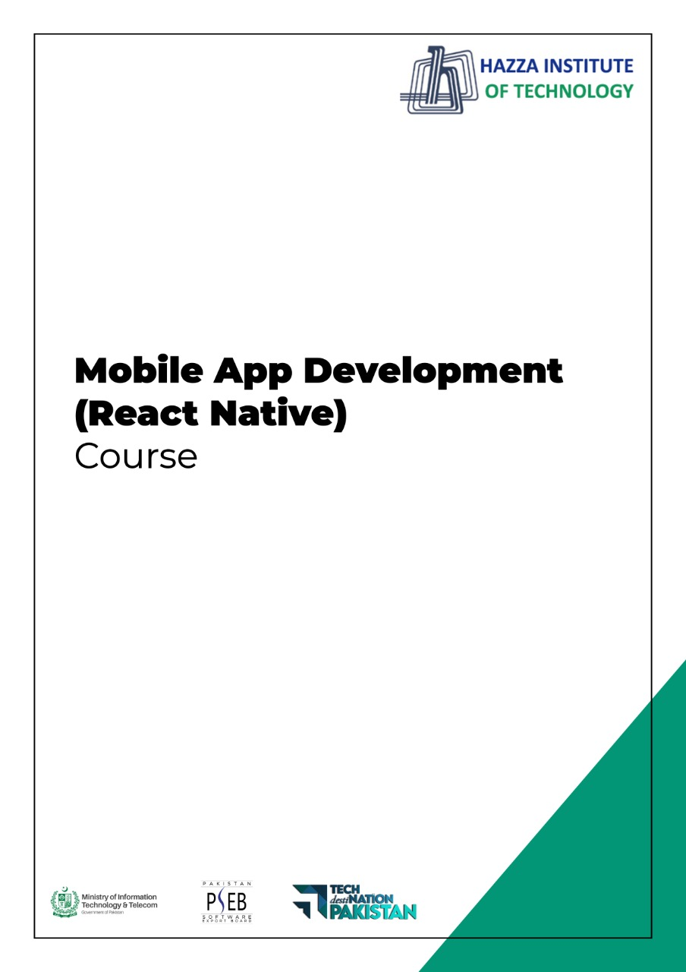
(Flutter)
Flutter Lab 6 (Session 2)

Total Time:
3 hours (sessions-1)

Pre-Lab Activities:
  - Student Must have Knowledge about Widget dart function.

Learning Outcomes:
  - Students will learn about external libraries
  - Students will learn the use of functions in Flutter
  - Students will learn more about layout widgets

Lab Task- 2:
In Lab Task 1, Expanded widgets are repeated seven times. Enclose Expended widgets in a function and call the this function seven time instead 7 Expanded block.
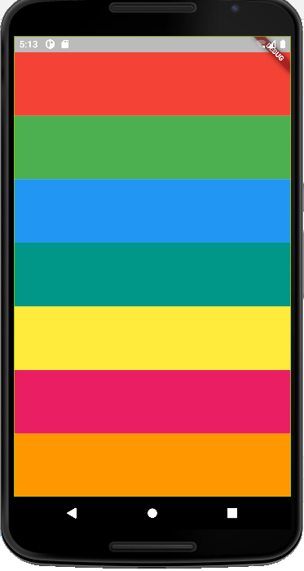
Create another function for sound and pass sound value to this function from onPressed callback function.

Lab Solutions:

LAB 6.2 :
import 'package:flutter/material.dart';
import 'package:audioplayers/audioplayers.dart';

void main() => runApp(MaterialApp(
home: xylophone(),
));

class xylophone extends StatelessWidget {
const xylophone({Key? key}) : super(key: key);
void soundPlayer(int note){ final player = AudioCache();
player.play('note$note.wav');}

Expanded xylophonefun({required Color color, required int soundPlay}){
return Expanded(
child: TextButton(
style: ButtonStyle(backgroundColor: MaterialStateProperty.all(color)),
onPressed: () { soundPlayer(soundPlay);
},
child: Text("Press Me"),
),
);
}

@override
Widget build(BuildContext context) {
return Scaffold(
backgroundColor: Colors.black,
appBar: AppBar(title: Text('Xylophone'),
),
body: SafeArea(

child: Container(

child: Column(
crossAxisAlignment: CrossAxisAlignment.stretch,
children: [
xylophonefun(color: Colors.orange, soundPlay: 1),
xylophonefun(color: Colors.yellow, soundPlay: 2),
xylophonefun(color: Colors.pink, soundPlay: 3),
xylophonefun(color: Colors.purple, soundPlay: 4),
xylophonefun(color: Colors.indigo, soundPlay: 5),
xylophonefun(color: Colors.red, soundPlay: 6),
xylophonefun(color: Colors.brown, soundPlay: 7),
],

),),

),
);
}
}

